ЛАБОРАТОРНА РОБОТА № 7
Створення веб-застосунків з підтримкою взаємодії в реальному часі з використанням SignalR
Варіант №8
Мета: отримати практичний досвід інтеграції SignalR у веб-застосунок для забезпечення обміну даними в реальному часі за допомогою SignalR.
Завдання 1.
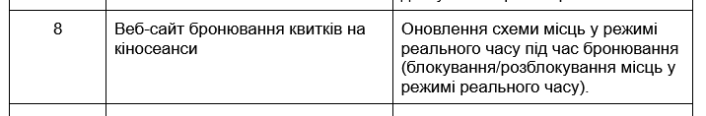
Лістинг
using Microsoft.AspNetCore.Mvc;
using Microsoft.AspNetCore.SignalR;
using RestAPI.Hubs;
using RestAPI.Models;
using System.Linq;
using System.Collections.Generic;

namespace RestAPI.Controllers
{
[ApiController]
[Route("api/[controller]")]
public class BookingController : ControllerBase
{
private readonly IHubContext<BookingHub> hubContext;

public BookingController(IHubContext<BookingHub> hubContext)
{
this.hubContext = hubContext;
}

[HttpGet("Seats")]
public IActionResult GetBookedSeats()
{
return Ok(BookingDataStore.GetBookedSeats());
}

[HttpPost("Confirm")]
public async Task<IActionResult> ConfirmBooking([FromBody] List<Seat> seats)
{
if (seats == null || !seats.Any())
{
return BadRequest(new { message = "No seats provided for booking." });
}

BookingDataStore.AddPermanentBookings(seats);

var updatedSeats = BookingDataStore.GetBookedSeats();
await hubContext.Clients.All.SendAsync("SeatsUpdated", updatedSeats);

return Ok(new { message = $"Booking confirmed for {seats.Count} seat(s)!", seats });
}

[HttpPost("Cancel")]
public async Task<IActionResult> CancelBooking([FromBody] List<Seat> seatsToCancel)
{
if (seatsToCancel == null || !seatsToCancel.Any())
{
return BadRequest(new { message = "No seats provided for cancellation." });
}

int removedCount = BookingDataStore.RemoveBookings(seatsToCancel);

if (removedCount == 0)
{
return NotFound(new { message = "Cancellation failed: None of the specified seats were found booked." });
}

var updatedSeats = BookingDataStore.GetBookedSeats();
await hubContext.Clients.All.SendAsync("SeatsUpdated", updatedSeats);

return Ok(new { message = $"Cancellation successful: {removedCount} seat(s) were released." });
}
}
}
using Microsoft.AspNetCore.SignalR;
using System.Collections.Concurrent;

namespace RestAPI.Hubs
{
public class BookingHub : Hub
{
private static readonly ConcurrentDictionary<int, bool> BookedSeats = new();

private static readonly ConcurrentDictionary<int, string> LockedSeats = new();

public async Task BookSeats(List<int> seatNumbers)
{
foreach (var seat in seatNumbers)
{
BookedSeats[seat] = true;
LockedSeats.TryRemove(seat, out _);
}

await Clients.All.SendAsync("SeatsUpdated", GetAllSeatStates());
}

public async Task LockSeats(List<int> seatNumbers)
{
var connectionId = Context.ConnectionId;

foreach (var seat in seatNumbers)
{
if (!BookedSeats.ContainsKey(seat))
{
LockedSeats[seat] = connectionId;
}
}

await Clients.All.SendAsync("SeatsUpdated", GetAllSeatStates());
}

public async Task UnlockSeats(List<int> seatNumbers)
{
var connectionId = Context.ConnectionId;

foreach (var seat in seatNumbers)
{
if (LockedSeats.TryGetValue(seat, out var lockerId) && lockerId == connectionId)
{
LockedSeats.TryRemove(seat, out _);
}
}

await Clients.All.SendAsync("SeatsUpdated", GetAllSeatStates());
}

public override async Task OnDisconnectedAsync(Exception? exception)
{
var connectionId = Context.ConnectionId;
var seatsToUnlock = LockedSeats
.Where(s => s.Value == connectionId)
.Select(s => s.Key)
.ToList();

foreach (var seat in seatsToUnlock)
{
LockedSeats.TryRemove(seat, out _);
}

await Clients.All.SendAsync("SeatsUpdated", GetAllSeatStates());
await base.OnDisconnectedAsync(exception);
}

public static List<SeatState> GetAllSeatStates()
{
return Enumerable.Range(1, 30).Select(seatNumber =>
{
if (BookedSeats.ContainsKey(seatNumber))
return new SeatState(seatNumber, "booked");
if (LockedSeats.ContainsKey(seatNumber))
return new SeatState(seatNumber, "locked");
return new SeatState(seatNumber, "free");
}).ToList();
}
}

public record SeatState(int Number, string Status);
}
using System.Collections.Generic;
using System.Linq;

namespace RestAPI.Models
{
public static class BookingDataStore
{
private static readonly List<Seat> PermanentBookedSeats = new List<Seat>
{
new Seat { Row = 1, Number = 3 },
new Seat { Row = 2, Number = 1 },
new Seat { Row = 2, Number = 2 }
};

public static IEnumerable<Seat> GetBookedSeats() => PermanentBookedSeats;

public static void AddPermanentBookings(IEnumerable<Seat> seats)
{
foreach (var seat in seats)
{
if (!PermanentBookedSeats.Any(s => s.Row == seat.Row && s.Number == seat.Number))
{
PermanentBookedSeats.Add(seat);
}
}
}

public static int RemoveBookings(IEnumerable<Seat> seatsToRemove)
{
int initialCount = PermanentBookedSeats.Count;

PermanentBookedSeats.RemoveAll(bookedSeat =>
seatsToRemove.Any(s => s.Row == bookedSeat.Row && s.Number == bookedSeat.Number));

return initialCount - PermanentBookedSeats.Count;
}
}

}
@page "/book"
@using BlazorApp1.Models
@using Microsoft.AspNetCore.SignalR.Client
@using System.Net.Http.Json
@inject HttpClient Http
@inject IJSRuntime JsRuntime
@inject NavigationManager Navigation

<PageTitle>Бронювання місць</PageTitle>

<div class="book-container py-5">
<div class="text-center mb-5">
<h1 class="fw-bold text-gradient mb-2">🎟️ Бронювання місць</h1>
<p class="text-muted lead">Оберіть бажані місця у залі кінотеатру</p>
</div>

<div class="alert alert-info shadow-sm text-center mb-4">
Ця сторінка доступна без авторизації.
</div>

<div class="row justify-content-center mb-3">
<div class="col-lg-8 col-md-7 text-center">
<div class="btn-group" role="group">
<button class="btn btn-outline-primary" @onclick="() => SetUnlockMode(false)" disabled="@(unlockMode == false)">Звичайний режим</button>
<button class="btn btn-outline-warning" @onclick="() => SetUnlockMode(true)" disabled="@(unlockMode == true)">Режим: розблокувати бронь</button>
</div>
<div class="mt-2 small text-muted">У режимі розблокування ви можете вибирати червоні (заброньовані) місця для скасування броні.</div>
</div>
</div>

<div class="row justify-content-center">
<div class="col-lg-8 col-md-7 mb-4">
<div class="card shadow-lg border-0 rounded-4">
<div class="card-header bg-success text-white text-center fw-semibold rounded-top-4">
🎬 Виберіть місця
</div>
<div class="card-body text-center p-4">
<h5 class="text-secondary mb-3">Екран</h5>
<div class="screen-bar mx-auto mb-4"></div>

@if (bookedSeats == null || lockedSeats == null)
{
<div class="text-muted">Завантаження інформації про місця...</div>
}
else
{
@for (int row = 1; row <= 4; row++)
{
<div class="seat-row mb-3">
<span class="row-label fw-semibold text-muted me-3">Ряд @row:</span>
@for (int number = 1; number <= 10; number++)
{
var seat = new Seat { Row = row, Number = number };
var isBooked = bookedSeats.Any(s => s.Row == row && s.Number == number);
var isLocked = lockedSeats.Any(s => s.Row == row && s.Number == number);
var isSelected = selectedSeats.Any(s => s.Row == row && s.Number == number);

bool disabled;
if (unlockMode)
{
disabled = isLocked && !isSelected;
}
else
{
disabled = isBooked || (isLocked && !isSelected);
}

var cssClass = isBooked ? "booked" : isLocked ? "locked" : isSelected ? "selected" : "";

<button type="button"
@onclick="() => ToggleSeat(seat)"
disabled="@disabled"
class="seat-btn @cssClass">
@number
</button>
}
</div>
}
}
</div>
</div>
</div>

<div class="col-lg-4 col-md-5">
<div class="card shadow-lg border-0 rounded-4 sticky-top" style="top: 90px;">
<div class="card-header bg-info text-white fw-semibold text-center rounded-top-4">
🧾 Ваш вибір
</div>
<div class="card-body p-4">
@if (selectedSeats.Any())
{
<ul class="list-group mb-4">
@foreach (var seat in selectedSeats.OrderBy(s => s.Row).ThenBy(s => s.Number))
{
<li class="list-group-item py-2 px-3 border-0 shadow-sm mb-2 rounded-3">
🎫 Ряд @seat.Row, Місце @seat.Number
</li>
}
</ul>

<div class="d-grid gap-2">
@if (!unlockMode)
{
<button class="btn btn-success w-100 btn-lg rounded-pill shadow-sm" @onclick="ConfirmBooking">
✅ Підтвердити (@selectedSeats.Count)
</button>
<button class="btn btn-secondary w-100 btn-lg rounded-pill shadow-sm" @onclick="CancelSelection">
🔓 Скасувати вибір
</button>
}
else
{
<button class="btn btn-danger w-100 btn-lg rounded-pill shadow-sm" @onclick="ConfirmUnlockBooked">
🔥 Підтвердити розблокування (@selectedSeats.Count)
</button>
<button class="btn btn-secondary w-100 btn-lg rounded-pill shadow-sm" @onclick="CancelSelection">
✖ Відмінити вибір
</button>
}
</div>
}
else
{
<p class="text-muted text-center">Будь ласка, оберіть місце.</p>
}

@if (!string.IsNullOrEmpty(bookingMessage))
{
<div class="alert @(bookingSuccess ? "alert-success" : "alert-danger") mt-4 text-center shadow-sm">
@bookingMessage
</div>
}

<hr />

<div class="small text-muted">
<strong>Легенда:</strong>
<div><span class="legend-box free"></span> Вільне</div>
<div><span class="legend-box selected"></span> Обрані вами</div>
<div><span class="legend-box locked"></span> Тимчасово заблоковане</div>
<div><span class="legend-box booked"></span> Остаточно заброньоване</div>
</div>
</div>
</div>
</div>
</div>
</div>

@code {
private List<Seat>? bookedSeats;
private List<Seat> lockedSeats = new();
private List<Seat> selectedSeats = new();
private string bookingMessage = string.Empty;
private bool bookingSuccess = false;
private HubConnection? hubConnection;
private bool unlockMode = false;

private readonly string apiBaseUrl = "https://localhost:5001";
private readonly string hubUrl = "https://localhost:5001/bookinghub";

public class Seat
{
public int Row { get; set; }
public int Number { get; set; }

public override bool Equals(object? obj) =>
obj is Seat other && Row == other.Row && Number == other.Number;

public override int GetHashCode() => HashCode.Combine(Row, Number);
}

protected override async Task OnInitializedAsync()
{
await StartSignalRConnection();
await LoadBookedSeats();
}

private void SetUnlockMode(bool value)
{
unlockMode = value;
selectedSeats.Clear();
StateHasChanged();
}

private async Task LoadBookedSeats()
{
try
{
bookedSeats = await Http.GetFromJsonAsync<List<Seat>>($"{apiBaseUrl}/api/Booking/Seats");
if (bookedSeats == null) bookedSeats = new List<Seat>();
}
catch
{
bookedSeats = new List<Seat>();
}
}

private async Task StartSignalRConnection()
{
hubConnection = new HubConnectionBuilder()
.WithUrl(hubUrl)
.WithAutomaticReconnect()
.Build();

hubConnection.On<List<Seat>>("SeatsUpdated", (updatedBooked) =>
{
bookedSeats = updatedBooked;
selectedSeats.RemoveAll(sel => bookedSeats.Any(b => b.Equals(sel)) && !unlockMode);
InvokeAsync(StateHasChanged);
});

hubConnection.On<List<Seat>>("SeatsLocked", (updatedLocked) =>
{
lockedSeats = updatedLocked;
selectedSeats.RemoveAll(sel => lockedSeats.Any(l => l.Equals(sel)) && !unlockMode);
InvokeAsync(StateHasChanged);
});

hubConnection.On<List<Seat>>("SeatsUnlocked", (updatedLocked) =>
{
lockedSeats = updatedLocked;
InvokeAsync(StateHasChanged);
});

try
{
await hubConnection.StartAsync();
Console.WriteLine("SignalR connected");
}
catch (Exception ex)
{
Console.WriteLine($"SignalR error: {ex.Message}");
}
}

private async Task ToggleSeat(Seat seat)
{
bool isBooked = bookedSeats.Any(s => s.Equals(seat));
bool isLocked = lockedSeats.Any(s => s.Equals(seat));
bool alreadySelected = selectedSeats.Any(s => s.Equals(seat));

if (!unlockMode)
{
if (isBooked) return;
if (isLocked && !alreadySelected) return;

if (alreadySelected)
selectedSeats.RemoveAll(s => s.Equals(seat));
else
selectedSeats.Add(seat);

if (hubConnection is not null)
{
try
{
await hubConnection.InvokeAsync("LockSeats", selectedSeats);
}
catch (Exception ex)
{
Console.WriteLine($"LockSeats invoke error: {ex.Message}");
}
}
}
else
{
if (!alreadySelected)
selectedSeats.Add(seat);
else
selectedSeats.RemoveAll(s => s.Equals(seat));
}

bookingMessage = string.Empty;
StateHasChanged();
}

private async Task CancelSelection()
{
if (!selectedSeats.Any()) return;

if (!unlockMode)
{
if (hubConnection is not null)
{
try
{
await hubConnection.InvokeAsync("UnlockSeats", selectedSeats);
}
catch (Exception ex)
{
Console.WriteLine($"UnlockSeats invoke error: {ex.Message}");
}
}

selectedSeats.Clear();
bookingMessage = "🔓 Вибір скасовано (тимчасові блокування знято).";
bookingSuccess = true;
}
else
{
selectedSeats.Clear();
bookingMessage = "Вибір розблокування скасовано.";
bookingSuccess = false;
}

StateHasChanged();
}

private async Task ConfirmBooking()
{
if (!selectedSeats.Any()) return;

bookingMessage = "Обробка...";
try
{
var response = await Http.PostAsJsonAsync($"{apiBaseUrl}/api/Booking/Confirm", selectedSeats);

if (response.IsSuccessStatusCode)
{
bookingSuccess = true;
bookingMessage = "✅ Бронювання успішно підтверджено!";
selectedSeats.Clear();
}
else
{
bookingSuccess = false;
var text = await response.Content.ReadAsStringAsync();
bookingMessage = $"❌ Помилка бронювання: {text}";
}
}
catch (Exception ex)
{
bookingSuccess = false;
bookingMessage = $"❌ Помилка: {ex.Message}";
}

StateHasChanged();
}

private async Task ConfirmUnlockBooked()
{
if (!selectedSeats.Any()) return;

bookingMessage = "Обробка розблокування...";
try
{
var response = await Http.PostAsJsonAsync($"{apiBaseUrl}/api/Booking/Cancel", selectedSeats);

if (response.IsSuccessStatusCode)
{
bookingSuccess = true;
bookingMessage = "✅ Розблокування успішне — місця знову вільні!";
selectedSeats.Clear();
await LoadBookedSeats();
}
else
{
bookingSuccess = false;
var text = await response.Content.ReadAsStringAsync();
bookingMessage = $"❌ Не вдалося розблокувати: {text}";
}
}
catch (Exception ex)
{
bookingSuccess = false;
bookingMessage = $"❌ Помилка: {ex.Message}";
}

StateHasChanged();
}

public async ValueTask DisposeAsync()
{
if (hubConnection is not null && selectedSeats.Any() && !unlockMode)
{
try
{
await hubConnection.InvokeAsync("UnlockSeats", selectedSeats);
}
catch
{
}
}

if (hubConnection is not null)
await hubConnection.DisposeAsync();
}
}
<style>
.book-container {
background: linear-gradient(135deg, #f9fafb 0%, #eef2ff 100%);
min-height: calc(100vh - 80px);
}

.text-gradient {
background: linear-gradient(90deg, #0d6efd, #6610f2);
-webkit-background-clip: text;
-webkit-text-fill-color: transparent;
}

.screen-bar {
width: 80%;
height: 8px;
background: linear-gradient(90deg, #007bff, #00c6ff);
border-radius: 10px;
box-shadow: 0 0 10px rgba(0, 123, 255, 0.3);
}

.seat-row {
display: flex;
justify-content: center;
align-items: center;
flex-wrap: wrap;
}

.row-label {
min-width: 70px;
text-align: right;
}

.seat-btn {
width: 40px;
height: 40px;
border: 2px solid #0d6efd;
border-radius: 8px;
background-color: #fff;
color: #0d6efd;
font-weight: 500;
transition: all 0.2s ease-in-out;
margin: 0 4px;
cursor: pointer;
}

.seat-btn:hover {
transform: scale(1.06);
}

.seat-btn.booked {
background-color: #dc3545;
color: white;
border-color: #dc3545;
cursor: pointer;
}

.seat-btn.locked {
background-color: orange;
color: white;
border-color: orange;
cursor: not-allowed;
}

.seat-btn.selected {
background-color: #ffc107;
border-color: #ffc107;
color: #212529;
}

.list-group-item {
background-color: #f8f9fa;
}

.btn {
transition: all 0.2s ease-in-out;
}

.btn:hover {
transform: scale(1.02);
}

.legend-box {
display: inline-block;
width: 14px;
height: 14px;
margin-right: 8px;
vertical-align: middle;
border-radius: 3px;
border: 1px solid #ccc;
}

.legend-box.free {
background: #fff;
}

.legend-box.selected {
background: #ffc107;
}

.legend-box.locked {
background: orange;
}

.legend-box.booked {
background: #dc3545;
}
</style>
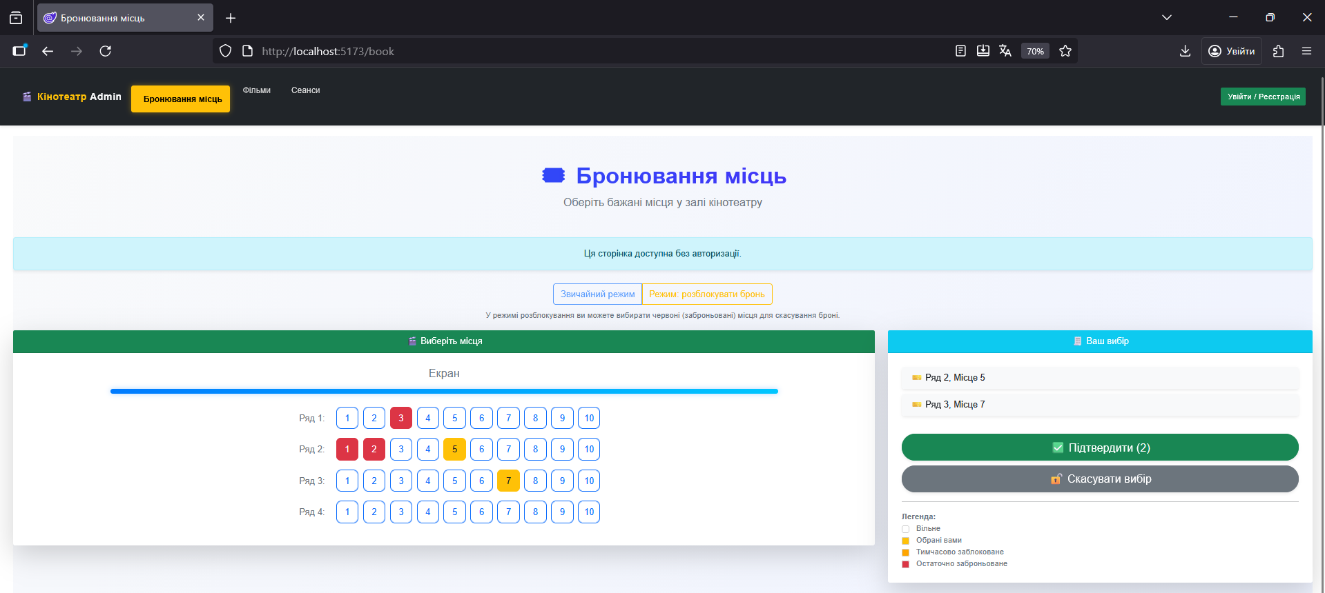
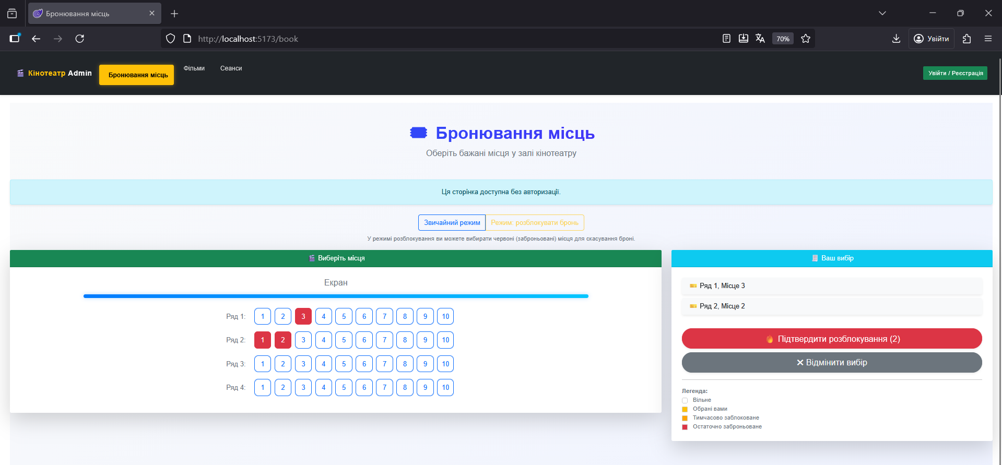
Рис. 1-2. Результат виконання програмного коду
Висновок: я отримав практичний досвід інтеграції SignalR у веб-застосунок для забезпечення обміну даними в реальному часі за допомогою SignalR.

